**Year Wise Price Using Line Graph:**

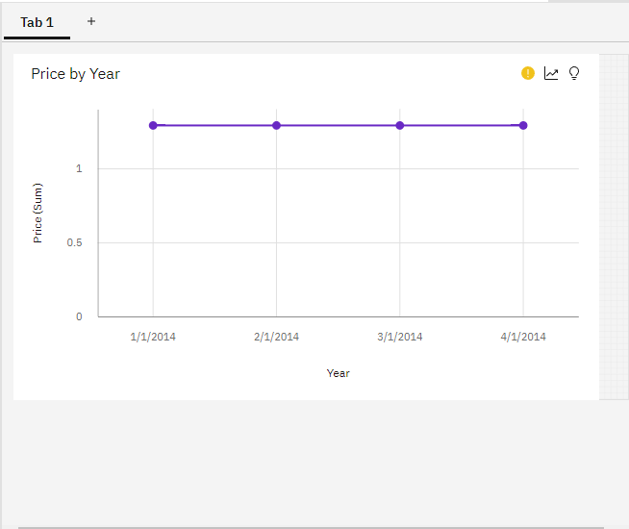

### Year Wise Stock Using Line Graph:

### C:\Users\M.Anu Priya\Pictures\Screenshots\Screenshot (14).png

### Top10 Sales by Year Using Line Graph:

### C:\Users\M.Anu Priya\Pictures\Screenshots\Screenshot (15).png

### Monthly Sales Using Tree Map:

### C:\Users\M.Anu Priya\Pictures\Screenshots\Screenshot (16).png

### Monthly Revenue by Pie Chart:

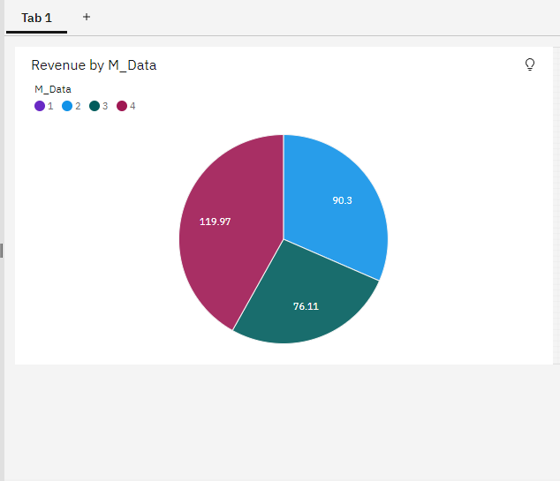

### Summary Cards of Total Revenue, Sales, Stock, Price:

### C:\Users\M.Anu Priya\Pictures\Screenshots\Screenshot (18).png

**Dashboard Creation:**

### C:\Users\M.Anu Priya\Pictures\Screenshots\Screenshot (19).png